**DAILY ONLINE ACTIVITIES SUMMARY**

|  |  |  |  |  |  |  |  |  |
| --- | --- | --- | --- | --- | --- | --- | --- | --- |
| **Date:** | **09/06/2020** | | | | | **Name:** | **SUAJANA** | |
| **Sem & Sec** | **IV sem & B section** | | | | | **USN:** | **4AL18CS089** | |
| **Online Test Summary** | | | | | | | | |
| **Subject** | | **-** | | | | | | |
| **Max. Marks** | | **30** | | **Score** | | | **-** | |
| **Certification Course Summary** | | | | | | | | |
| **Course** | **Java Programming** | | | | | | | |
| **Certificate Provider** | | | **Greatlearning academy** | | **Duration** | | | **5.5 hours** |
| **Coding Challenges** | | | | | | | | |
| **Problem Statement1:** Write a C Program to rotate the matrix by K times. | | | | | | | | |
| **Status: Executed** | | | | | | | | |
| **Uploaded the report in Github** | | | | | **YES** | | | |
| **If yes Repository name** | | | | | **Online-coding** | | | |
| **Uploaded the report in slack** | | | | | **YES** | | | |

Online Test Summary: No internals conducted today.

Online Certification Course Summary: In today’s session I have learnt about variables and data types in java and also about operators in java and also about flow control statement in java.

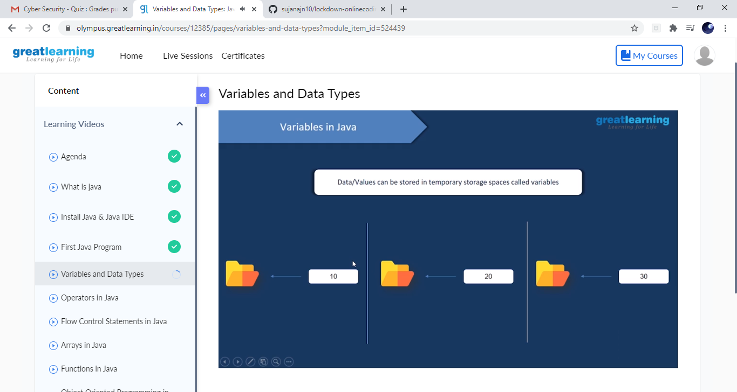

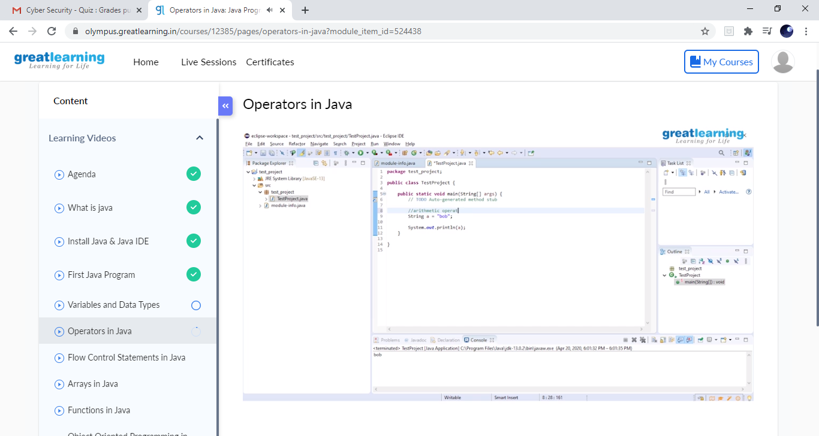

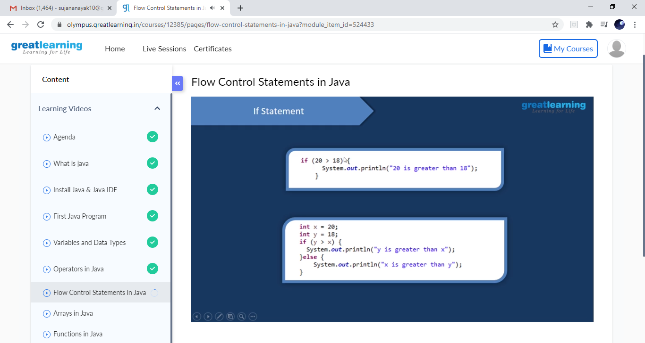

These are the snap shots of today’s sessions.

Online Coding Summary: **Today I had received one program from prof.Venkatesh CSE Dept. The program is mentioned above in the coding challenges. I have also uploaded it to my Github repository.**

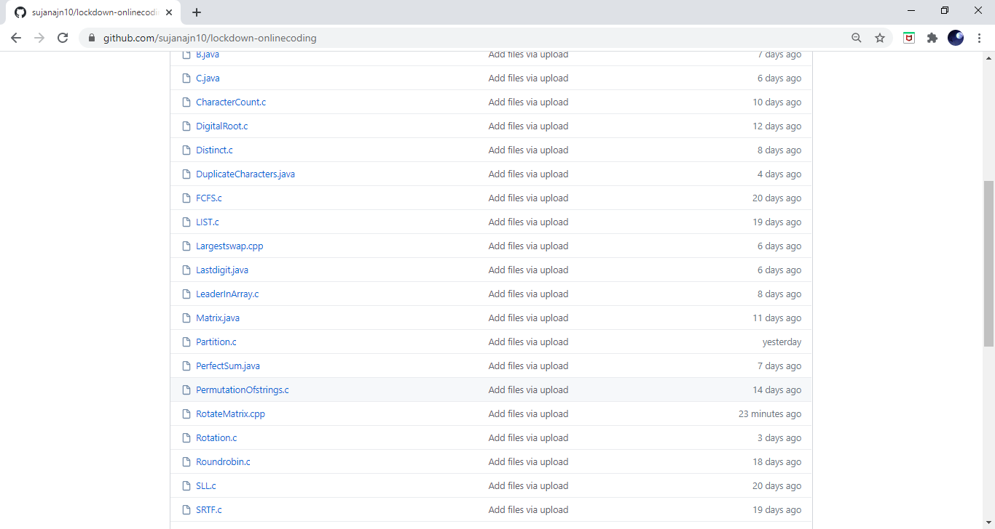

**This is the snap shot of my repository** were I have uploaded the code. File name is RotationMatrix.cpp